**CS 457/557 -- Winter Quarter 2018**

**Project #5**

**Giraffe Poster: Mirrors & Glass**

Stewart Rodger

rodgers@oregonstate.edu

02/27/2018

For this assignment I chose to recreate the natural pattern on a giraffe using noisy ellipsis, however instead of using solid colors I chose to make the spots reflective and the base refractive. Unfortunately, after a few failed attempts to use my own images for the cube mapping, I chose to go with the Nvidia images provided in the class.

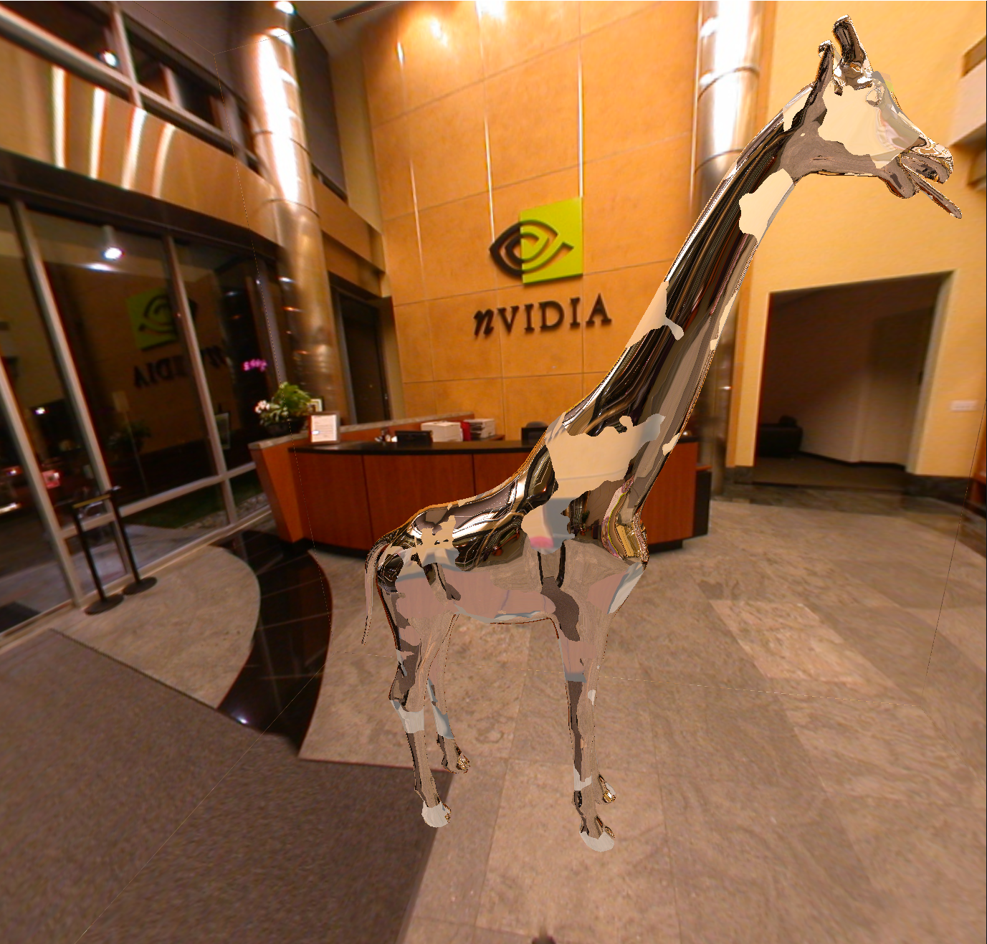

The key parts of the noisy ellipsis are similar to the ones from project 2, with reflection or refraction added based on where the pixel was located.

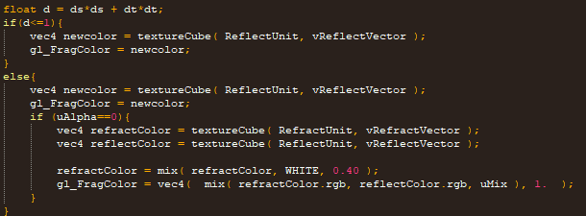

Demonstration:

<https://media.oregonstate.edu/media/t/0_8nm2pjf0>